## Neuralynx FFT Utility

## Installation

This application requires Matlab or Matlab(T) Runtime, (MCR, version 7.17(2012a). Go to <http://www.mathworks.com/products/compiler/mcr/index.html?s_cid=BB> to download and install the proper MCR for your platform. Installing the MCR will not affect previous MCR installations.

**Browse** to the folder with the unzipped files. There are two options in running the application:

|  |  |
| --- | --- |
| MCR is installed on your computer: | **Click on StartNlxFFT.exe**. |
| Matlab installed on your computer: | Add the folder/subfolders to your Matlab path and **type StartNlxFFT, press enter.** |

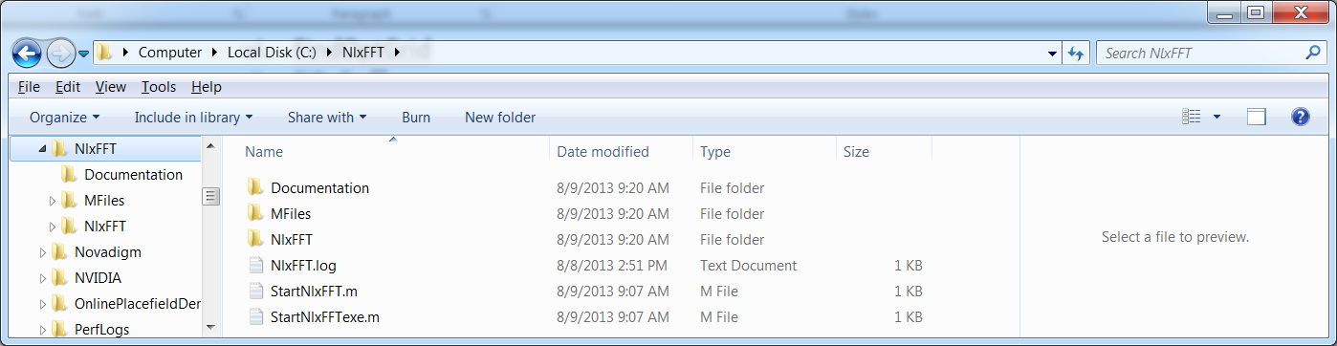

You should see

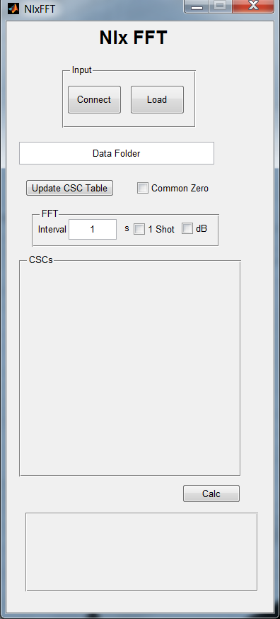

The application has two modes: online and offline. Online connects directly to Cheetah through NetCom(T), while offline is used for viewing of stored CSC files.

## Online Mode

**Click on 'Connection'** to bring up the connection GUI. With Cheetah running, **Connect** to local host, an appropriate IP address, or Computer Name. The GUI will minimize once you have connected.

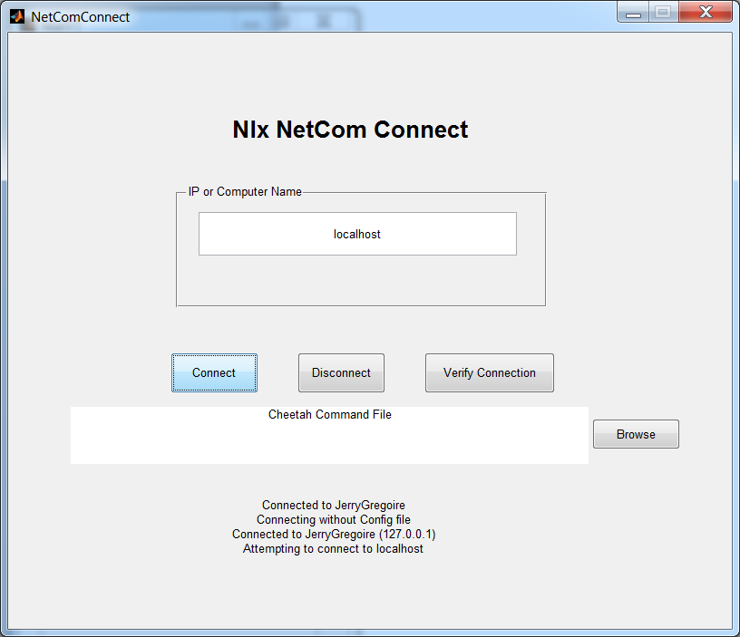

On the NlxFFT GUI, **press Update CSC Table** to retrieve the CSC entities from Cheetah.

## Offline Mode

**Click on 'Load' and** **browse** to the folder containing the CSC files you wish to view. ***Offline mode loads the entire CSC. If you load large files, the calculation will be significantly slower.***

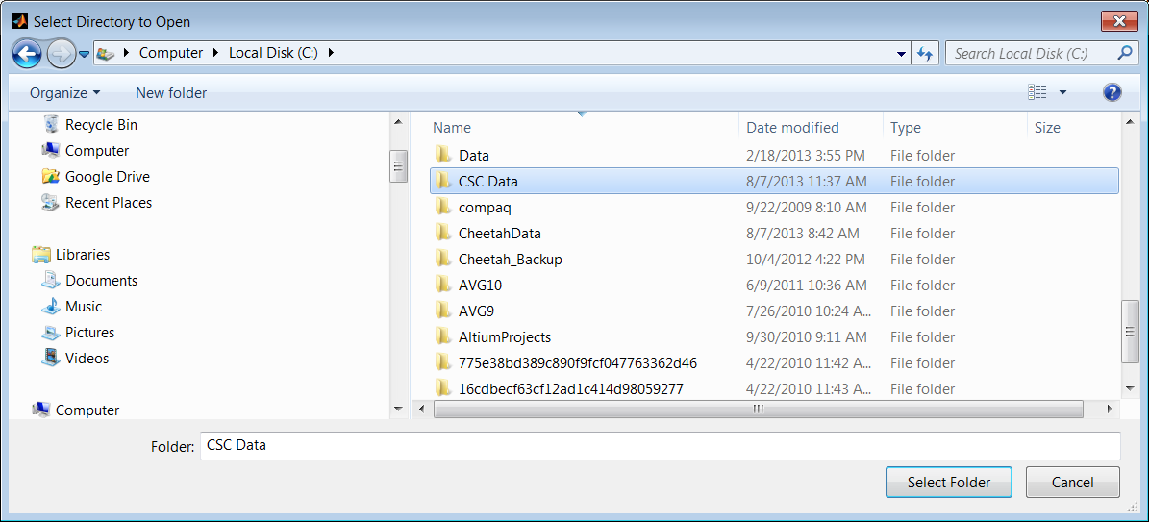

# Setup

**Click on the CSC checkboxes** to choose the CSCs you want to analyze. In the online mode, you can select the length of the time interval. You may also choose single shot or continuous updating. Both online and offline modes allow either a linear or decibel display. You also have the option of displaying each CSC independently or overlaid, (common zero), for direct comparison.

# Run

**Press Calc**, a figure will appear with the FFTs in subplots. If it does not respond, try clicking on Calc again. Depending on where Matlab is in the timer call, it occasionally does not recognize a click.

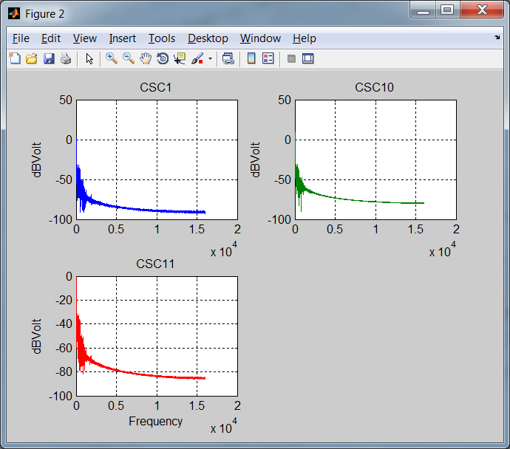

Return to the NlxFFT GUI, **Click 'CommonZero'**. This will superimpose all FFTs on the same figure. You will need to **click 'Calc'** again.

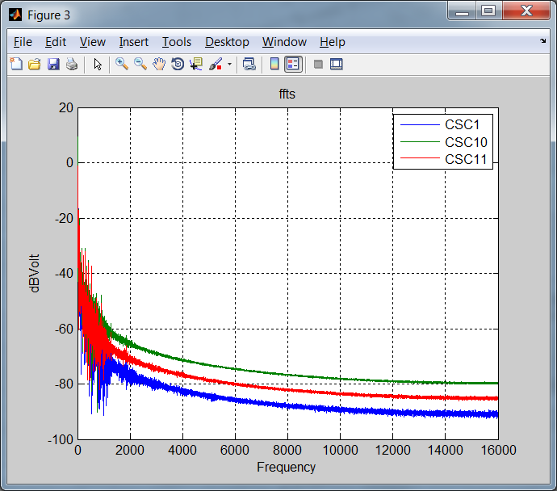

Note that you can use the Matlab zoom functions. Click on the appropriate magnifying glass and right click to select your zoom type.

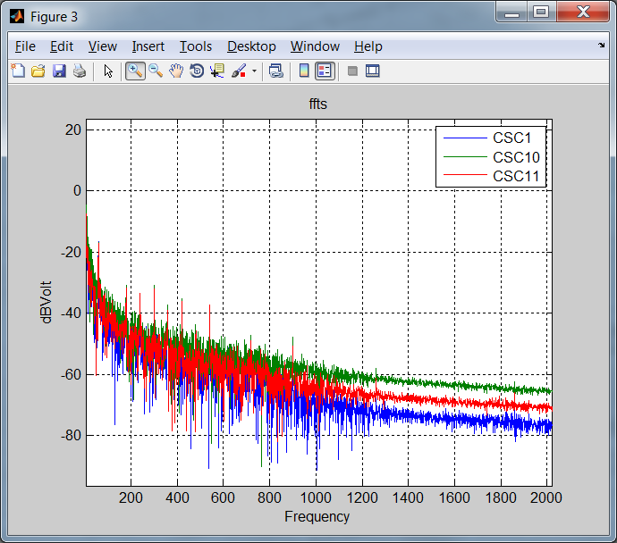

If you are online with a non-zero interval, the plots will continually update. **Click 'Calc' to stop** calculations.